Click  ¶  button in toolbar to make form background visible. Background will not print.

To insert a hazard pictogram, click “Insert” menu, then select “Quick Parts” drop down. Place pictogram in center of red diamond. Test print for accuracy. Delete these instructions.

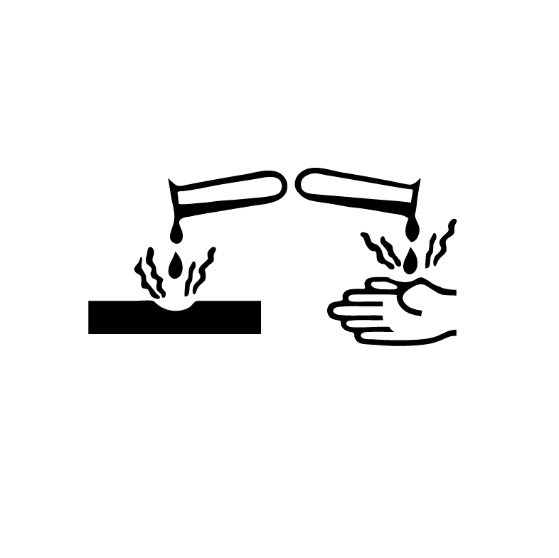

Insert Hazard Text